**CISM 314 PRACTICAL 2.**

**INTRODUCTION TO ASSEMBLY LANGUAGE.**

**GROUP NAME: MARSHALLS**

**GROUP MEMBERS:**

**Nyameni M.P**

**Mooketsi T.P**

**Molema R**

**AIM**

To write a program in Assembly using the MARIE Simulator to find the sum of the following equation and store and display the output.

**W = X + Y – Z**

**INTRODUCTION**

This lab was conducted to find the sum of two numbers using a program written in Assembly language called MARIE. The practical was to introduce Assembly language and help get a better understanding of what Assembly language is and how it works.

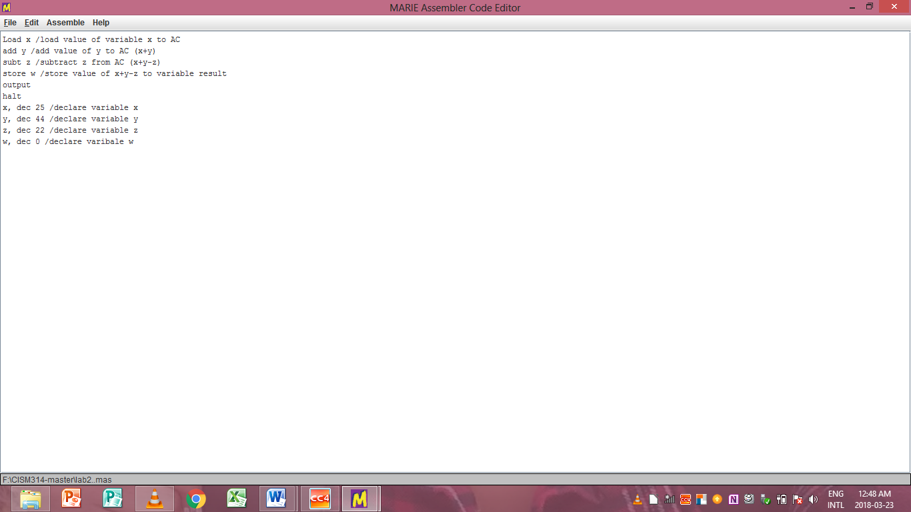

Figure 1

Figure 1 represents the code of the sum of the equation in the MARIE simulator. Declaration of the variables is done and each variable is assigned a value that is given from the question. The code is for to load, add, sub and output is written in the MARIE assembler code editor.

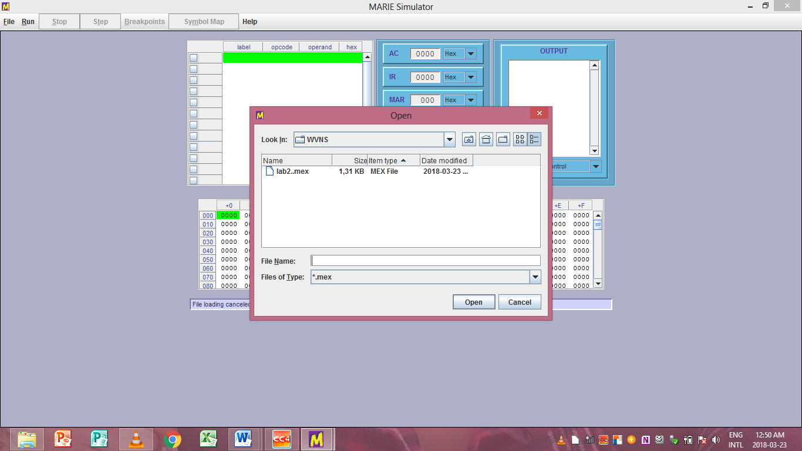

Figure 2

Figure 2 represents running the code written in the MARIE code editor in the MARIE stimulator

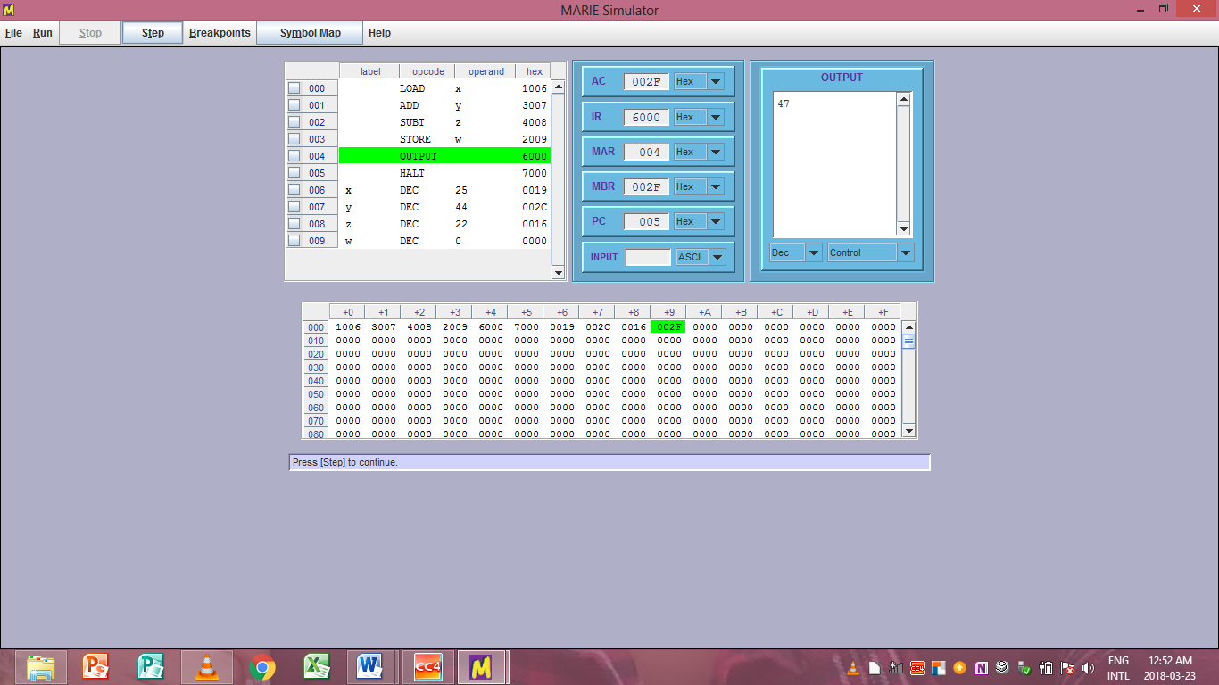

Figure 3

Figure 3 represents the variables being shown in the stimulator with their values and the code being stimulated and the output is then processed and displayed in the output box shown in the picture.

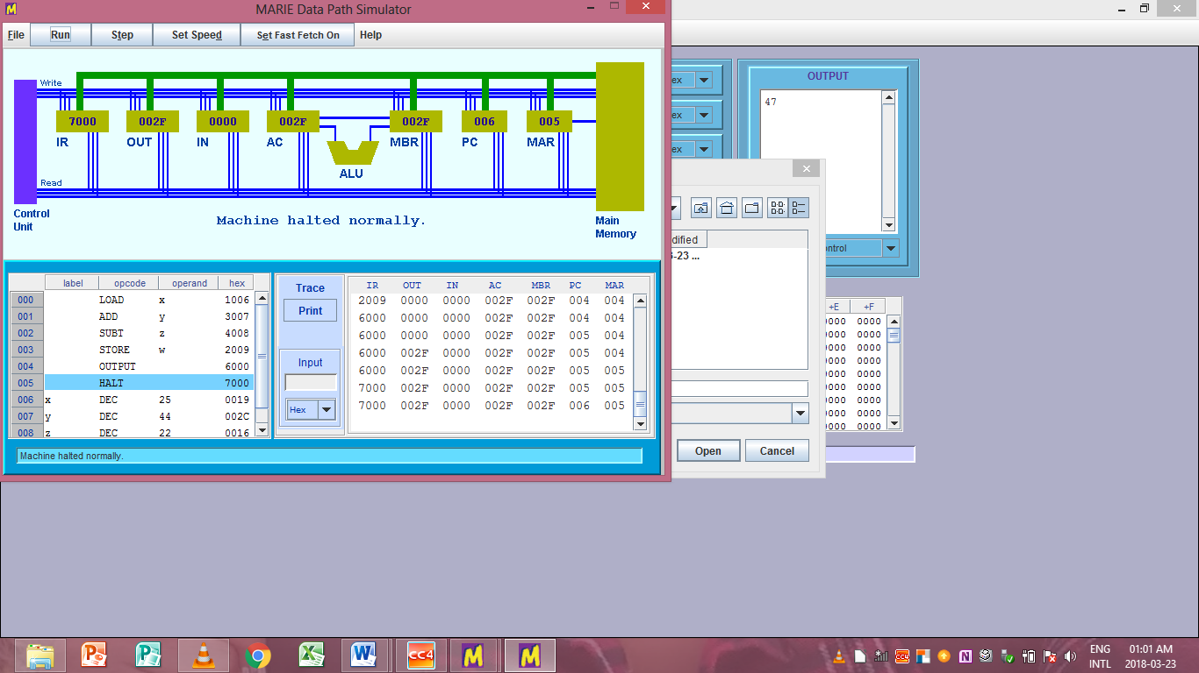

Figure 4

Figure 4 represents the MARIE data path stimulator and the code that is run in the MARIE stimulator and this shows the path being transferred from the CPU to the main memory and the machine is halted normally.

**CONCLUSION**

In conclusion, the program was written in Assembly using the MARIE Simulator to find the sum of the following equation and store and display the output as shown in the above figures.